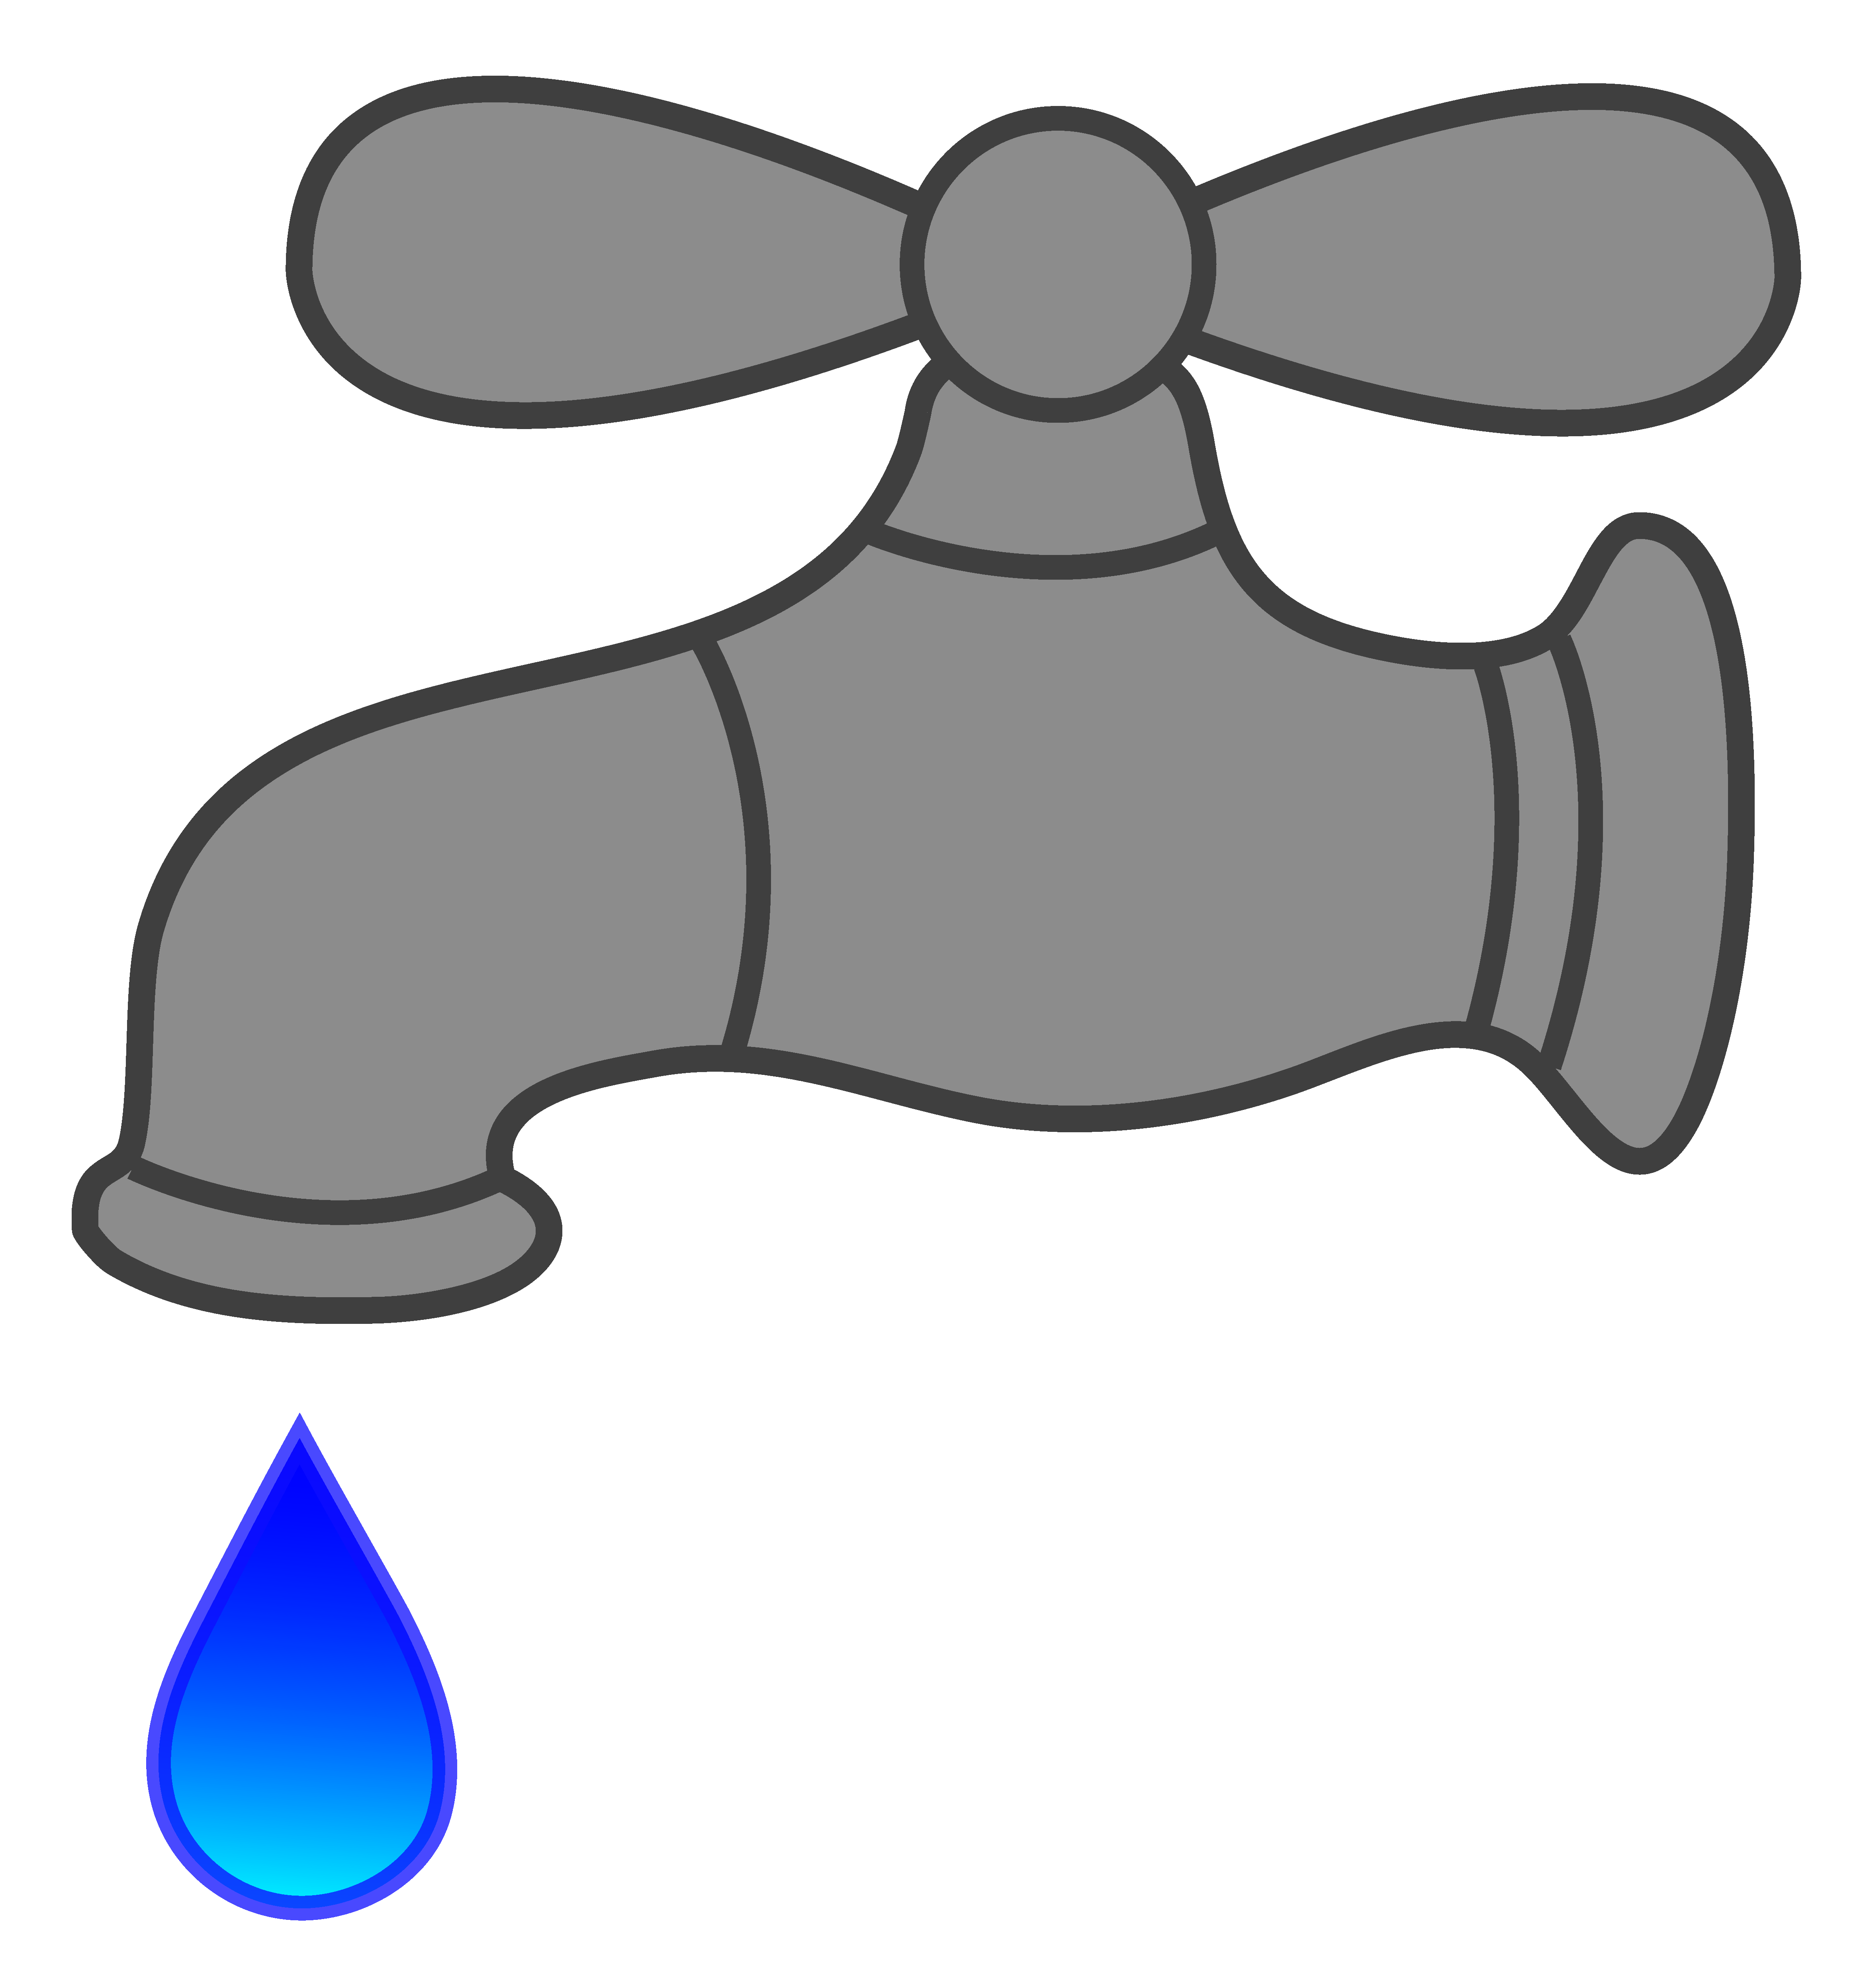
Village of Waverly Water Department

WATER MAIN CONTRUCTION
Water mains are being replaced

Starting on or about Monday, October 12, 2023 until completed.
Dates are estimated.

You may experience loss of water service and cloudy/discolored water, which should only last a few hours.

If water is cloudy or discolored, run water through outside hose and all faucets making sure you remove aerator/screen from faucet until water is clear.

Vehicles will need to be moved off of roads/side of the roads while work is being done. Roads may be closed or partially closed during construction

We apologize for any inconveniences that this may cause.

Patrick Roney
Chief Operator Water Department

