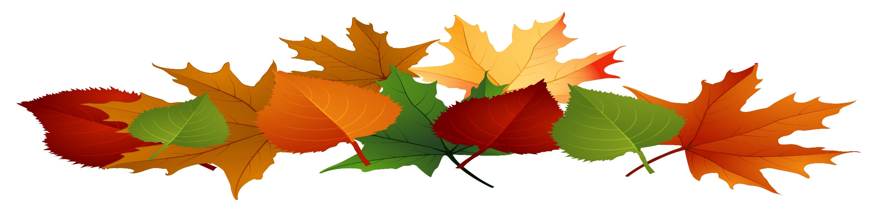

Village of Waverly

Fall leaf clean up

Friday, October 21, 2022 – Friday, December 2, 2022

Weather Permitting

